DMS Assignment 3 – Public Chat Room

Developed by Andy Li (0777899)

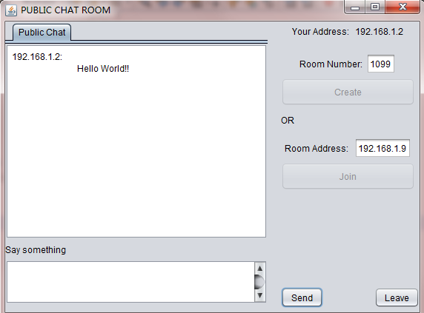

Functions:

* You can create a chat room by selecting a room number and clicking “Create”.
* OR if you know there is already a chat room, you can enter the Room Address and click “Join”.
* When you are in a chat room you can type in your message in the bottom text area, and click “Send” to send your message.
* You can also leave the chat room by clicking “Leave”.

This program is developed based on RMI.